Cybersecurity Lab Report: Task 1
Candidate Name: Anjali Kumari
ID – APSPL2631216
Date of Assigning: 21 March, 2026
Date of Submission: March 26, 2026
Subject: Foundation & Environment Setup
Platform: ApexPlanet Cybersecurity Fast-Track

1. Executive Summary
The objective of this assignment was to establish a functional, isolated virtualization lab for penetration testing. The setup involves a Kali Linux attacker machine and a Metasploitable 2 victim machine connected via a private Host-Only network. This report demonstrates foundational skills in network analysis, service scanning, cryptography, and basic web exploitation.
2. Lab Environment Configuration
To ensure a safe testing environment, both virtual machines were configured using a Host-Only Adapter. This prevents any exploit traffic from leaking onto the public internet while allowing the two machines to communicate.
2.1 Network Verification (ifconfig)
I verified the IP address of the Kali Linux machine to ensure it was within the correct subnet (192.168.56.x).
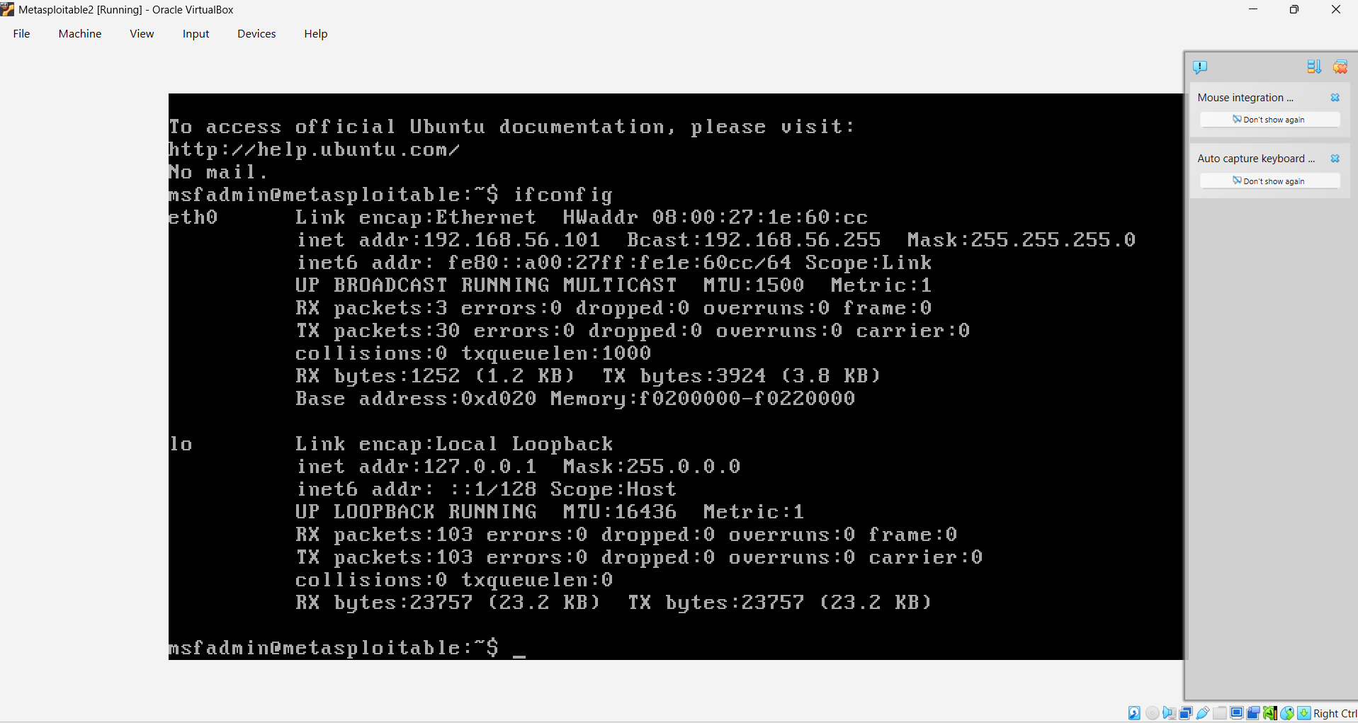
3. Networking & Traffic Analysis
Using Wireshark, I monitored the network interface to observe real-time traffic between the host and the target.
3.1 Packet Capture (ICMP)
I initiated a ping command from Kali to the Metasploitable 2 IP address. The capture shows the ICMP Request and Reply packets, confirming a successful "handshake" between the two systems.
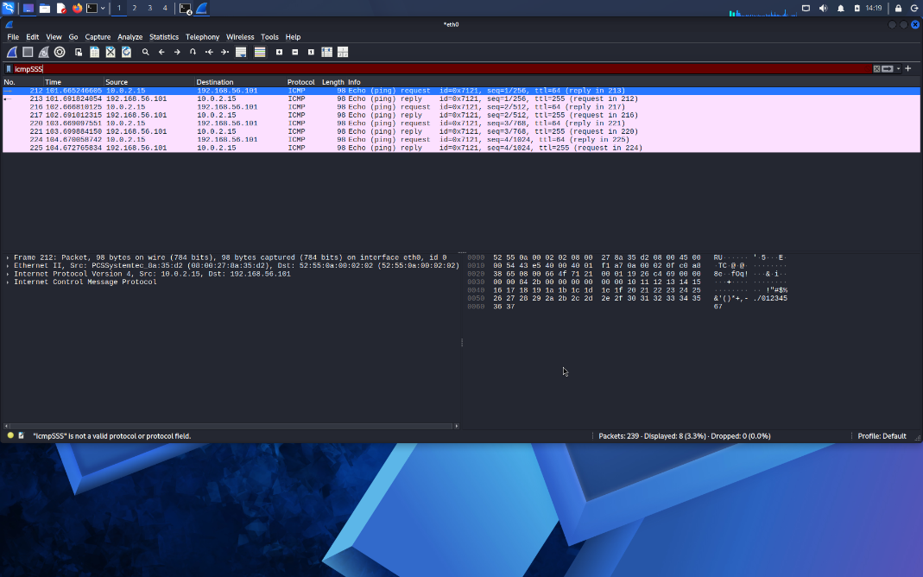
4. Information Gathering (Nmap)
I conducted a service version scan (nmap -sV) against the target IP. This is a critical step in the reconnaissance phase of a penetration test to map the "Attack Surface."
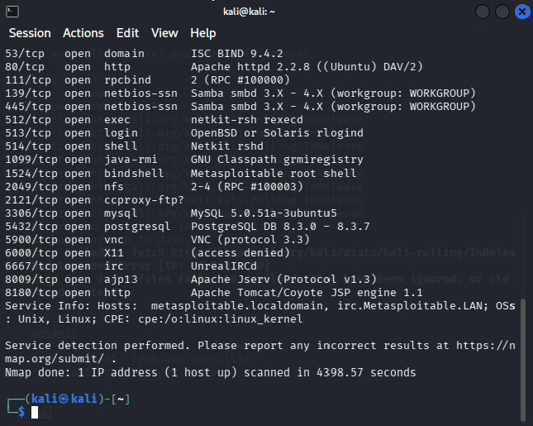
5. Cryptography Basics (OpenSSL)
To demonstrate data protection, I used OpenSSL to encrypt a sensitive text file using the AES-256-CBC algorithm. This proves the ability to secure data at rest.
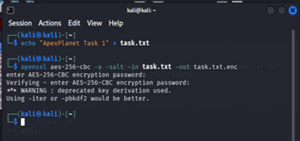
6. Tool Familiarization (Netcat)
I utilized Netcat (nc) to establish a raw network connection between two terminal sessions. This simulates how an attacker might establish a "Bind Shell" or "Reverse Shell" for communication.
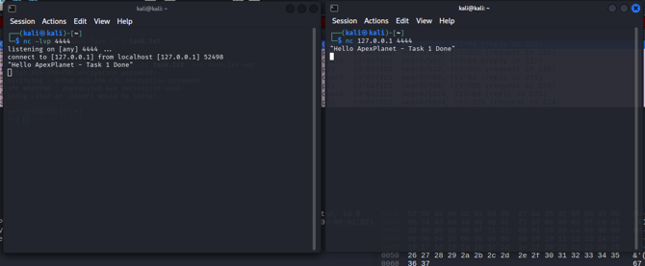
7. Proof of Exploitation (DVWA)
As a final proof of concept, I accessed the DVWA (Damn Vulnerable Web App) on the target machine. I successfully performed a Command Injection by appending a Linux command to the IP input field.
- Command Used: 127.0.0.1; whoami
- Result: The server executed the command and returned www-data. 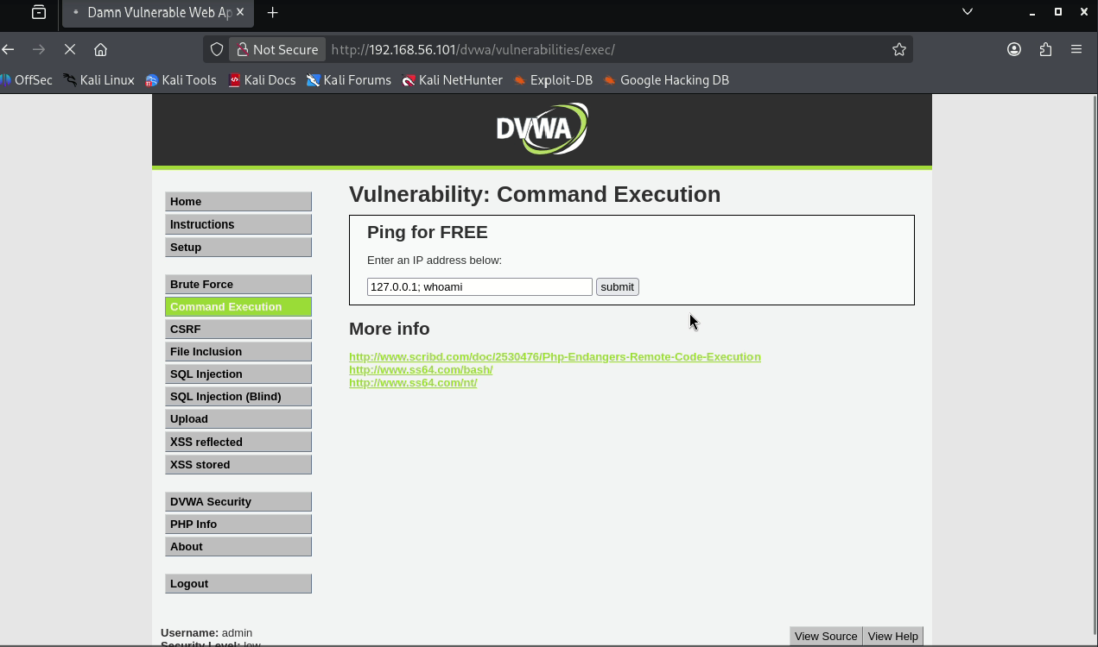
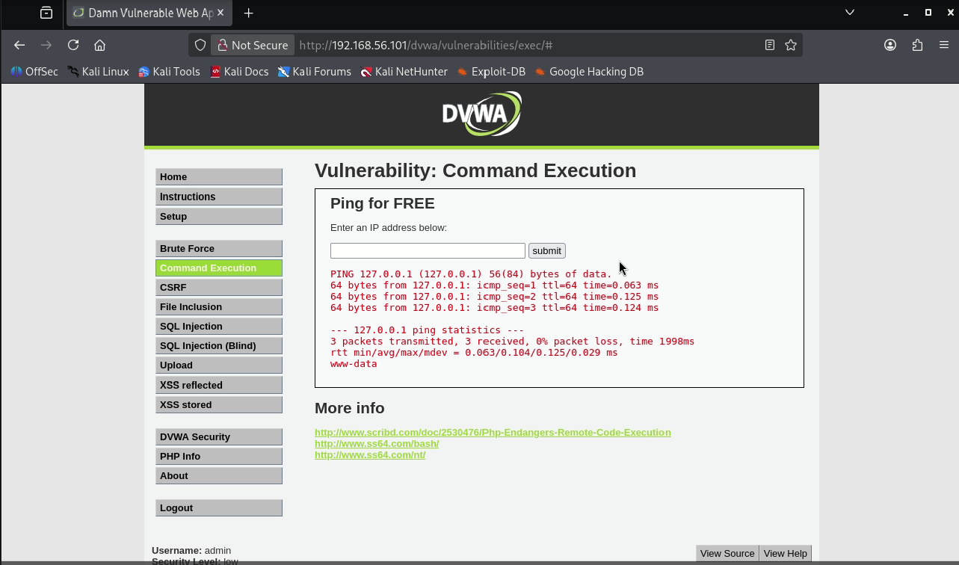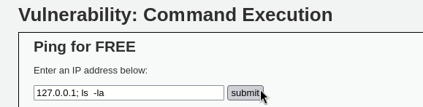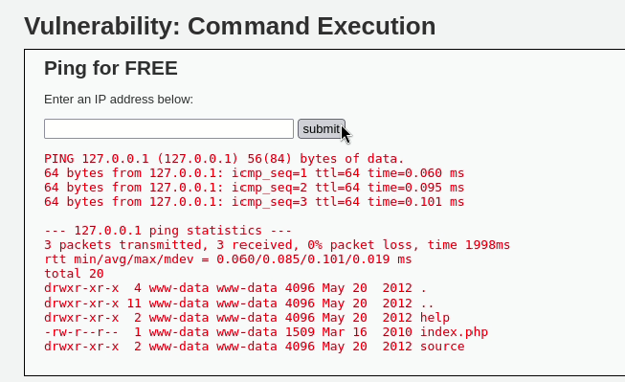
9. Conclusion
Task 1 has been successfully completed. The lab environment is stable, connectivity is verified, and foundational security tools have been mastered.

